AIM:

TO STUDY

THE PRESENCE OF

OXALATE ION IN

GUAVA FRUIT.



**BONAFIDE CERTIFICATE**

   Certified that _______________ of standard **XII** studying in Amrita Vidyalayam, Chennai has successfully completed the project on ________ during the Academic year 2024-2025 under my guidance for AISSCE (All India Senior Secondary Certificate Examination) 2024-25.

DATE:

**Teacher in charge                                                                 Principal’s signature**(Mr. Swaminathan)                                                                                 (Mrs.Vani Srinivasan)

External Examiner:  
  
  
  
  
  
School seal:

INTRODUCTION:

Guava:

Guava, (Psidium guajava), small tropical tree or shrub of the family Myrtaceae, cultivated for its edible fruits. Guava trees are native to tropical America and are grown in tropical and subtropical areas worldwide.

Guava fruits are processed into jams, jellies, and preserves and are common pastry fillings. Fresh guavas are rich in vitamins A, B, and C; they are commonly eaten raw and may be sliced and served with sugar and cream as a dessert.

Guava fruit today is considered minor in terms of commercial world trade but is widely grown in the tropics, enriching the diet of hundreds of millions of people in the tropics of the world.

Guava has spread widely throughout the tropics because it thrives in a variety of soils, propagates easily, and bears fruit relatively quickly. The fruits contain numerous seeds that can produce a mature fruit-bearing plant within four years

Oxalate:

Oxalic acid is a common organic compound. A range of living organisms — including fungi, bacteria, plants, animals, and humans — produce it.

Technically, oxalate occurs when the oxalic acid in plants binds to minerals. However, many people use the terms interchangeably.

The body can either produce oxalate as a waste product or obtain it from the diet.

Oxalate can combine with other minerals in the body to form compounds such as calcium oxalate and iron oxalate. People can then eliminate these oxalate compounds in the urine or stool.

However, some individuals with high oxalate levels may develop kidney stones.

For this reason, some people refer to oxalic acid, or oxalate, as an anti-nutrient.

The formula of the compound is H2C2O4. It is a relatively strong organic acid, being about 10,000 times stronger than acetic acid. The dianion, known as oxalate, is also a reducing agent and a ligand in coordination chemistry.

Daily Life Applications of Guava:

1. **May Reduce Cancer Risk**
   * Rich in antioxidants that neutralize cell-damaging free radicals
   * It may help protect against certain cancers
   * Test tube studies show guava extracts inhibit cancer cell growth
2. **Boosts Immunity**
   * Excellent source of immune-strengthening vitamin C
   * Filled with antioxidants that help the immune system by supporting it
   * Helps in the process of producing white blood cells that help fight infections
3. **Alleviates Menstrual Cramps**
   * Has pain-relieving and soothing properties
   * Eases cramps and discomfort during periods
   * Makes menstrual symptoms more manageable

MATERIALS REQUIRED:

Apparatus required:

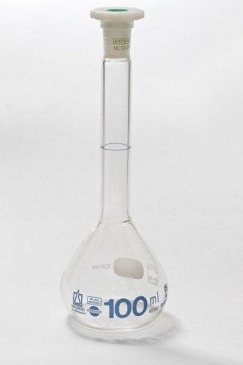 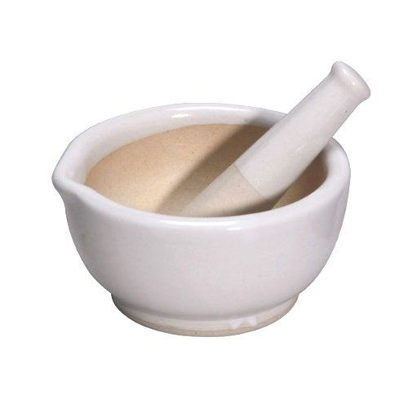 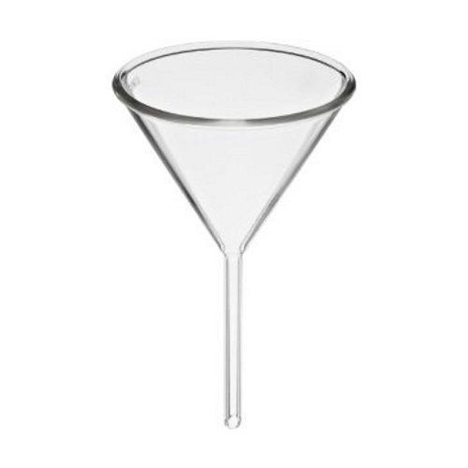Measuring flask Mortar & Pestel Funnel

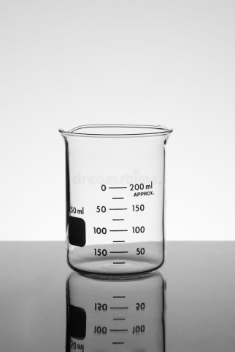 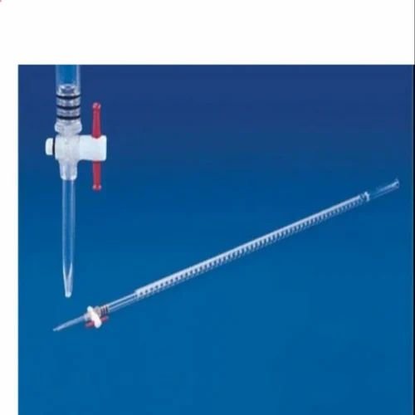

Beaker Burette

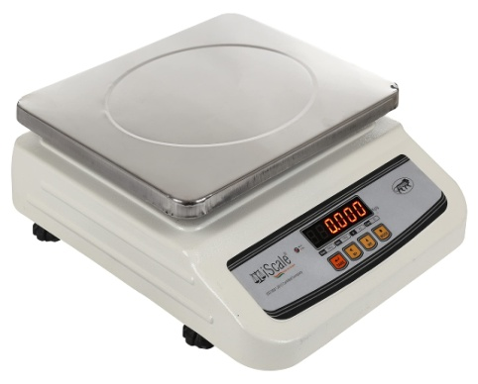 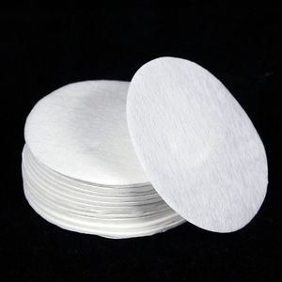

Weighing Machine Filter Paper

Guava fruit at different stages:

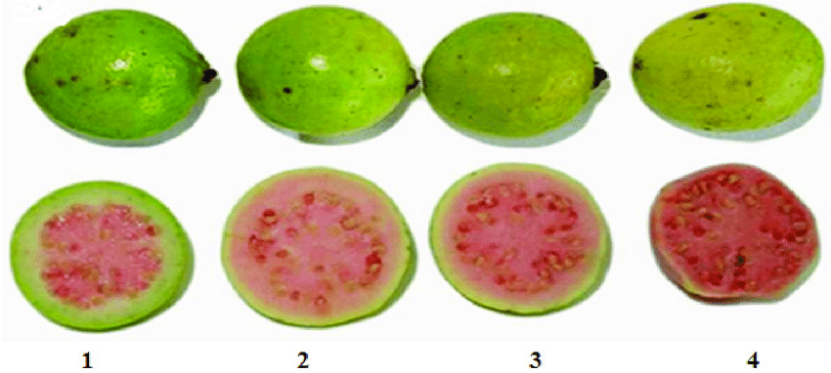

Chemicals required:

* Dil.H2SO4
* (N/10) KMnO4 solution

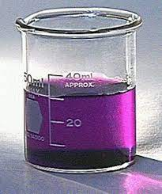

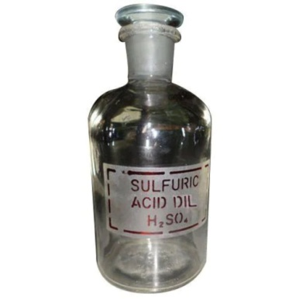

THEORY:

Oxalate ions are extracted from the Guava fruit by boiling the pulp with dilute H2SO4.zz

The oxalate ions are estimated volumetrically, by the titrating the solution with KMNO4 solution.

End point:

Appearance of permanent pale pink color.

PROCEDURE:

1. Weigh 50g of fresh guava & crush it to a fine pulp using pestle-mortar.
2. Transfer the crushed pulp to a beaker & add about 50ml dil.H2SO4 to it. Boil the contents for about 2 minutes.
3. Cool & filter the contents in a 100ml measuring flask. Make the volume up to 100ml by adding distilled water.
4. Take 20 ml of the solution from the measuring flask into a titration flask & add 20 ml of dil.H2SO4 to it. Heat the mixture to about 60oC & titrate it against N/20 KMNO4 solution taken in a burette till the end point had an appearance of pale pink color.
5. Repeat the above experiment with 50g of 1 day, 2 day and 3 day old guava fruits.

MOLECULAR EQUATIONS:

2KMnO4 + 3H2SO4 > K2SO4 + 2MnSO4 + 2H2o + 4[O]

HOOC-COOH.2H2O = [O]  60-70`C > 2C02 + 2H2O x 5

3KMnO4 + 3H2SO4 + 5HOOC-COOH.2H2O >

K2so4 + 2mNso4 + 18H2O + 10CO2

IONIC EQUATIONS:

MnO4−+8H++5e− > Mn2++4H2O×2

C2O42− > 2CO2+2e−×5

2MnO4–+16H+ 5C2O42-> 2Mn2+ + 10CO2 + 8H2O

OBSERVATION:

Weight of the Guava fruit taken :- 50.0g.

Volume of the Guava extract taken in titrations :- 20.0 ml

Normality of KMnO4 solution = 1/20.

End point : Color changes to pink.

| Guava solution | Burette reading initial | Final reading | Volume of KmnO4 | Concordant reading |
| --- | --- | --- | --- | --- |
| Raw | 150 | 18 | 132 | 136.06 |
| Semi ripened | 150 | 13 | 137 |
| Ripened | 150 | 10.8 | 139.2 |

CALCULATIONS:

1. For raw guava:

N1V1 = N2V2

N1 x 10 = (1/10) x 132

N1 = 132/100 = 1.32

Strength of oxalate in fresh guava extract

= normality x Eq. mass of oxalate ion

= 1.32/100 x 44g/ litre of diluted extract

= 0.581gL-1

1. For semi ripened guava(1 day old):

Strength of oxalate in one day old guava extract

=1.37/199 x 44g/ litre of diluted extract

=0.612 gL-1

1. For ripened guava:

Strength of oxalate in ripened guava extract

=1.39/100 x 44g /litre of diluted extract

=0.612 gL-1

Result:

1. The normality of oxalate ions of:
2. Fresh guava solution is = 1.32 N
3. Semi-ripen guava solution is = 1.37 N
4. Ripened guava solution is = 1.39 N
5. The strength of oxalate ions of:
   1. Fresh guava solutions is = 0.58 gL-1
   2. Semi-ripen guava solution is = 0.60 gL-1
   3. Ripened guava solution is = 0.61 gL-1

Precautions:

* There should be no parallax while taking measurements.
* Spillage of chemicals should be checked.
* Avoid the use of burette having a rubber tap as KMnO4 attacks rubber.

Sources of error:

* Burette having a rubber tap may be used.
* Dil.H2SO4 may be spilled while adding or it may not be added.

CONCLUSION:

* Oxalic acid and oxalates are abundantly present in many plants, most notably in sour grass, and sorrel (including oxalis), roots and leaves of rhubarb and buckwheat.
* After doing this experiment we can conclude that unripe guava has a high content of oxalate ions. The concentration of oxalate ions decreases with the ripening of fruit.
* This indicates the presence of oxalate ion in guava fruit.
* The content of oxalate ion in guava was found to be 59.67 percent, which is close to the literature value of 60 percent.
* It was also noticed that the content of oxalate ion grows with ripening of guava.

BIBLIOGRAPHY:

   

* NCERT Class 11 & 12 Chemistry Book.
* [www.google.com](http://www.google.com)
* <http://www.drive.google.com>
* <http://www.youtube.com>
* <http://www.slideshare.net>
* <http://www.scribd.com>
* Wikipedia.